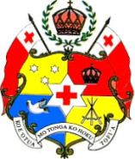
GOVERNMENT OF TONGA
MEDIA RELEASE
(26th September, 2025)

“UNGA80: Tonga participates in high-level solutions dialogue on Accelerating Early Warning Solutions.”

On 22 September 2025:-Tonga participated in the High-Level Solutions Dialogue on Accelerating Early Warning and Extreme Heat Solutions, held on the margins of the 80th Session of the United Nations General Assembly (UNGA80) in New York. The event was convened today just days ahead of the UN Climate Summit 2025.

The Dialogue highlighted the urgent need to strengthen early warning systems, address growing risks from extreme heat, and ensure solutions are adequately scaled, financed, and integrated across all sectors.

Early warning systems are proven to save lives, yet significant gaps remain, particularly for vulnerable communities.

Tonga was represented by the Deputy Permanent Representative to the United Nations, Mr Leonaitasi Kuluni.

-ENDS-

